Region IX Gila County, AZ

MIP Case Number 20-09-0049S Deliverable

Base Level Engineering

FEMA IDIQ Contract: HSFE60-15-D-0005

Task Order #:  70FBR9-19-F-00000174

March 28, 2022

Table of Contents

1. Scope 1

2. Topographic Processing 3

3. Development of Hydrologic Data 3

3.1 Stream Network Preparation and Watershed Delineation 3

3.2 Peak Flows Computed from Rural Regression Equations 6

3.2.1 North Gila 6

3.2.2 South Gila 7

3.3 Post-Burn Hydrology Tool 9

4. One-Dimensional Hydraulic Analysis 10

4.1 Discharges 11

4.2 Boundary Conditions 11

4.3 Stream Centerlines 11

4.4 Cross Sections 11

4.5 Ineffective Areas 12

4.6 Channel Banks and Overbank Flow paths 12

4.7 Manning’s n Values 12

4.8 Expansion and Contraction 13

4.9 Bridges and Culverts 13

4.10 Special Issues 14

4.11 Floodplains and Water Surface Elevation Grids 14

4.12 BFE Proxy Cross Sections 16

4.13 Quality Review 17

5. Two-Dimensional Hydraulic Analysis 17

5.1 Floodplain Mapping for 2D Model Results 19

6. Deliverables 21

7. References 23

Appendix 1 Region IX Geodatabase Documentation 1-1

Appendix 2 BLE Hydrologic Process Flowchart 2-1

Appendix 3 BLE Hydraulic QAQC Checklist 3-1

Appendix 4 Manning’s n Values 4-1

Tables

Table 3‑1: Spatial files delivered for stream network preparation and watershed delineation 5

Table 3‑2: Spatial files delivered for the computation of peak flows from unregulated regression equations for the north Gila study area 7

Table 3‑3: Spatial files delivered for the computation of peak flows from unregulated regression equations for the south Gila study area 8

Table 3‑4: Percent Runoff Increases 9

Table 4‑1: Assumed pier widths as a function of average span width 13

Table 4‑2: Assume deck thickness as a function of average span width. 13

Figures

Figure 1‑1: Gila County BLE Study Map 2

Figure 3‑1: Sinks modeled in the gravel mining area near the City of Miami. 4

Figure 4‑1: Post processed floodplain to add backwater areas along a modeled reach that would be flooded but were not reflected in the hydraulic model, typically these occur as small tributaries join a larger reach. 15

Figure 4‑2: The post processing of floodplains also adds backwater areas upstream of the hydraulic model, these areas have the projected water surface from the most upstream cross section. 16

Figure 5‑1: Mesh alignment allows for flow across road embankment 18

Figure 5‑2: Larger roads or grid alignment may require adjustment of the grid to prevent flow impediment 19

Figure 6‑1: BLE deliverable folder structure 23

List of Acronyms

AEP Annual Exceedance Probability

BFE Base Flood Elevation

BLE Base Level Engineering

DEM Digital Elevation Model

DWR Department of Water Resources

FEMA Federal Emergency Management Agency

LiDAR Light Detection and Ranging

NAD North American Datum of 1983

NED National Elevation Dataset

NHD National Hydrography Dataset

PRISM **P**arameter-elevation **R**egressions on **I**ndependent **S**lopes **M**odel

USDA U.S. Department of Agriculture

USGS U.S. Geological Survey

# Scope

Base Level Engineering (BLE) hydrologic analysis has been completed to support flood risk analysis in Gila County, Arizona. The study was divided into two separate geographic areas: North Gila and South Gila. The 1D and 2D study streams and hydrologic watersheds are shown on the study map in Figure 1-1 below. This report includes the processing of topographic data, hydrologic data development, hydraulic data development, and floodplain mapping.

* Topographic processing included the resampling of available Light Detection and Ranging (LiDAR) data.
* Hydrologic data consisted of preparing a stream network, delineation of watersheds, development of gridded input parameters and peak flows from rural regression equations.
* A spreadsheet calculator was developed for the post-burn hydrology to estimate appropriate modifiers, which were then applied to various pre-fire event discharges as a means to determine and evaluate post-burn discharges by event.
* Hydraulic data consisted of developing 1D and 2D HEC-RAS models for the 10%, 4%, 2%, 1%, 1%-minus, 1%-plus, and 0.2% annual exceedance probability (AEP) events. Hydraulic models were only developed in areas within the LiDAR footprint.
* Floodplain polygons for the 1% and 0.2% AEP events.
* Water surface elevation and dept grids for the 10%, 4%, 2%, 1%, 1%-plus, and 0.2% AEP events.
* Proxy base flood elevations (BFEs) attributed with the 100-year water surface elevation for mapped reaches.

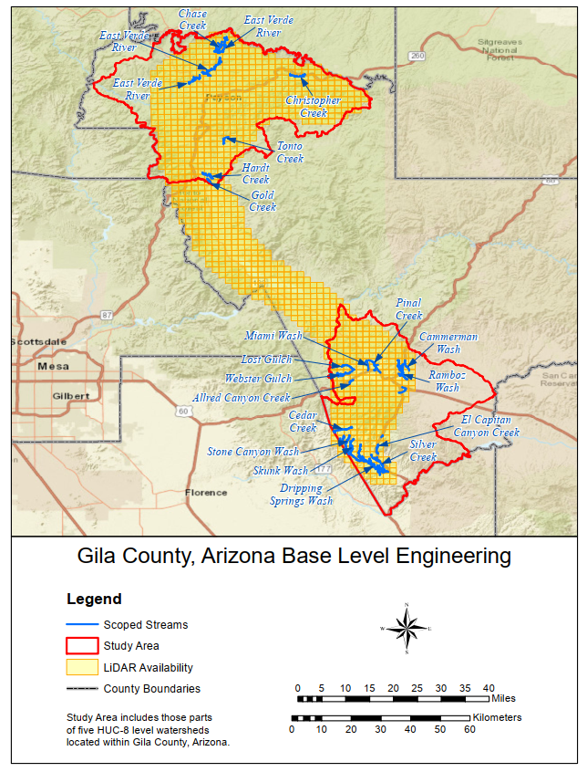

Figure 1‑1: Gila County BLE Study Map

# Topographic Processing

Two sets of topographic data were developed, one for hydraulic analysis and one for hydrologic data.

LiDAR (USGS and Woolpert, July 2019) was provided by the Region. Bare earth Digital Elevation Models (DEM) were provided as raster image (.img) files with a horizontal datum of NAD83 (North American Datum) (2011), a vertical datum of NAVD88, State Plane Arizona Eastern Zone (FIPS Zone 0201), units of international feet, and 3-foot cell sizes. For hydraulic analysis, the LiDAR was resampled to 5 feet.

For hydrologic analysis, the LiDAR was resampled to 3 meters, and horizontal and vertical units converted to meters. For the portions of the watershed outside of the LiDAR coverage, National Elevation Dataset (NED) 1/3 arcsecond topography was used, re-projected to State Plane Arizona Central Zone (in meters) and resampled to 3-meter cells. The datasets were mosaiced into a single grid for use in the hydrologic calculations.

# Development of Hydrologic Data

Peak flow estimates for the 10%, 4%, 2%, 1%, 1%-minus, 1%-plus, and 0.2% AEP events were derived using the rural regression equations presented in “Methods for Estimating Magnitude and Frequency of Floods in Arizona, Developed with Unregulated and Rural Peak-Flow Data through Water Year 2010” (Paretti et al. 2014), using primarily automated techniques. There were no gages along the study streams with an adequate period of record to perform flow frequency analyses.

A grid was generated for each of the regression parameters and each of the flow events described above. Each grid cell has a value for the drainage area and other regression parameters associated with the basin draining to that cell.

The process used to develop the hydrologic data is shown in a flowchart in Appendix 2. The primary steps were:

1. Prepare stream network, hydrologic network, and delineate watersheds.
2. Develop gridded input parameters and peak flows from the rural regression equations.
3. Spot check computed parameters and flow with StreamStats values.
4. A spreadsheet calculator was developed for the post-burn hydrology to estimate appropriate modifiers which would be applied to various pre-fire event discharges as a means to determine and evaluate post-burn discharges by event.

The details for each of these steps are included in the following sections.

## Stream Network Preparation and Watershed Delineation

The steps used to develop the stream network, delineate watersheds, and compute drainage areas are listed below:

1. Initially, the approximate contributing basins for those reaches for which hydraulic models were required were identified using NHD Plus (<http://www.horizon-systems.com/nhdplus/>) flow direction grids and watersheds. No streams with contributing flow outside the basin were identified.
2. A 3-meter DEM topography set was created as described in Section 2.
3. In the south Gila study area, there are gravel mining activities that have altered the natural flow paths and stream alignments near the City of Miami as shown in . It is assumed that there are no outflows from the deeper mining pits. Sinks were inserted in the mining pits as shown in the figure below. A sink is added to the terrain by converting a DEM cell to a "null" value. When sinks are inserted, the flowlines terminate at the sink. Sinks were only inserted where it was believed with a high degree of confidence that the 500-year event would not have sufficient volume to overflow the depression.

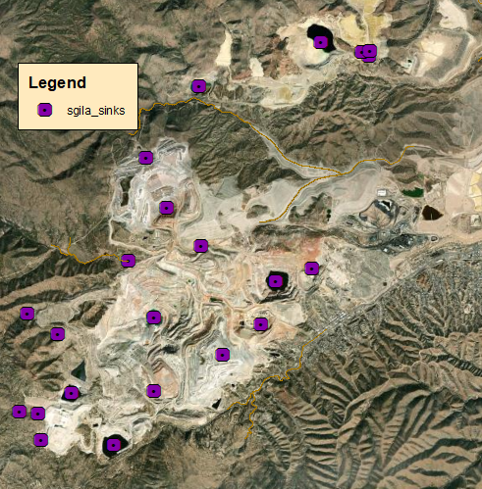Figure 3‑1: Sinks modeled in the gravel mining area near the City of Miami.

1. The DEM was then filled to remove other depressions so there were continuous flow paths to the basin outlets
2. A flow direction grid was created from the filled DEM, where each cell points to the next downstream cell.
3. Watershed delineation was performed (i.e., flowlines and basins were created from the flow direction grids). Basins were delineated up to a threshold of 0.1 square mile, and hydrologic flowlines were also created up to the 0.1 square mile of drainage area, which is the threshold recommended for hydrologic computations.
4. The hydrologic flow paths were reviewed for reasonableness, especially near roads and lakes/ponds.
5. At locations where the roads in the topography artificially diverted the computed flow path from the natural flow path, burn lines were drawn across the road, as well as through the lakes/ponds and corresponding spillways.
6. These burn lines were used to lower the elevations of the DEM cells that crossed them.
7. The modified DEM was then used to re-create the flow direction and flow accumulation grids, as well as the hydrologic basins and flow paths, following Steps 4 through 6 above.
8. The results were reviewed and burn lines added and adjusted, as appropriate, until the flow paths were reasonable.
9. A drainage area grid was computed along the flow paths.
10. The following quality checks were performed:
11. Delineated watersheds, flow lines, and drainage areas were examined for consistency with the expected flow paths for the basins based on the National Hydrography Dataset (NHD) and StreamStats networks.
12. Where noticeable differences were observed, the LiDAR topography was reviewed to determine the correct path.
13. If modifications were made to the burn lines, the fill / flow direction / watershed delineation steps were repeated, drainage areas recalculated, and the flagged locations checked again.

The delivered spatial files are in the Supplemental data folder. There are different folders for the north and south Gila study areas. described in Table 3‑1 below. All files listed below were projected in State Plane Arizona Eastern Zone, meters.

Table 3‑1: Spatial files delivered for stream network preparation and watershed delineation

| File Name | Type | Description |
| --- | --- | --- |
| ngila_hydrology_poly.shp  sgila_hydrology_poly2.shp | polygon | Polygons depicting the hydrologic study areas |
| ngila_topo.bil  sgila_topo.bil | grid | Mosaiced 3-meter DEMs |
| sgila_sinks.shp | point | Points where sinks are inserted into the terrain |
| ngila_burn.shp | polyline | Burn lines |
| ngila_fd.bil  sgila_fd.bil | grid | Flow direction grids |
| ngila_fa.bil  sgila_fa.bil | grid | Flow accumulation grid |
| ngila_basinpolys_0.1.shp  sgila_basinpolys_0.1.shp | polygon | Basins delineated up to a threshold of 0.1 square mile of drainage area |
| ngila_basinpaths_0.1_join.shp  sgila_basinpaths_0.1_join.shp | polyline | Hydrologic flow paths up to 0.1 square mile of drainage area. Each path has a unique stream ID that is similar to the stream order used to name the streams in the hydraulic models and determine where flows can be extracted from the flow grids |
| ngila_basinpolys_1.shp  sgila_basinpolys_1.shp | polygon | Basins delineated up to a threshold of 1 square mile of drainage area |
| ngila_basinpaths_1_join.shp  sgila_basinpaths_1_join.shp | polyline | Hydrologic flow paths up to 1 square mile of drainage area |

## Peak Flows Computed from Rural Regression Equations

Peak flow estimates for the 10%, 4%, 2%, 1%, 1%-minus, 1%-plus, and 0.2% flood events were derived using the rural regression equations presented in in “Methods for Estimating Magnitude and Frequency of Floods in Arizona, Developed with Unregulated and Rural Peak-Flow Data through Water Year 2010” (Paretti et al. 2014), using primarily automated techniques. Flow grids were developed for each flow event and input parameters for drainage areas of 0.1 square mile or greater.

### North Gila

The north Gila watersheds are within the Central Highlands regression region where the regression parameters are drainage area, basin average precipitation, and basin average elevation.

A grid of contributing drainage (in square miles) was created for all drainage areas of 0.1 square miles or greater.

The mean annual precipitation (1971-2000) gridded spatial data was obtained from PRISM (<http://www.prism.oregonstate.edu/>). The precipitation values were converted to inches, clipped to the study area, and reprojected to State Plane Arizona Eastern Zone, meters. A grid of the area-weighted basin average precipitation was created for all the drainage areas of 0.1 square mile or more.

The basin average elevation in feet was computed using the 3-meter topo described in the previous section.

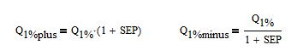The average standard errors of prediction (*SEP*) for the 1% event are 27.1% in the Central Highlands Region. The 1% plus and 1% minus gridded flows were computed using the SEP as shown in the equation below:

The flows for the entire north Gila study area were computed for the Central Highlands region using the equations in Table 9 of the USGS report (Paretti et al. 2014). The delivered spatial files are described in Table 3‑2 below. All files listed below were projected State Plane Arizona Eastern Zone, meters.

Table 3‑2: Spatial files delivered for the computation of peak flows from unregulated regression equations for the north Gila study area

| File Name | Type | Description |
| --- | --- | --- |
| ngila_sqmi.tif | grid | Contributing drainage area in square miles for all drainage areas of 0.1 square mile or greater |
| ngila_precip.bil | grid | PRISM precipitation grid clipped to the contributing drainage area, reprojected to State Plane Arizona Eastern Zone, meters, adjusted to 3-meter grid cells, and converted to inches |
| ngila_basinavgprecip.tif | grid | Area-weighted basin average precipitation for all drainage areas of 0.1 square mile or greater clipped to the associated regression region upper and lower limits |
| ngila_basinavgelev.tif | grid | Area-weighted basin average elevation for all drainage areas of 0.1 square mile or greater clipped to the associated regression region upper and lower limits |
| ngila_Q10_final.tif | grid | Regression equation peak flows for the 10% event |
| ngila_Q25_eqs_final.tif | grid | Regression equation peak flows for the 4% event |
| ngila_Q50_final.tif | grid | Regression equation peak flows for the 2% event |
| ngila_Q100_final.tif | grid | Regression equation peak flows for the 1% event |
| ngila_Q100_final.tif | grid | Regression equation peak flows for the 1% minus event |
| ngila_Q100_minus1_final.tif | grid | Regression equation peak flows for the 1% minus event |
| ngila_Q100_plus1_final.tif | grid | Regression equation peak flows for the 1% plus event |
| ngila_Q500_final.tif | grid | Regression equation peak flows for the 0.2% event |

### South Gila

The south Gila watersheds are within the both the Central Highlands and Southeastern Basin and Range regression regions. The regression equation parameters for the Central Highlands region include drainage area, basin average precipitation, and basin average elevation. There is only one parameter, which is drainage area, for the Southeaster Basin and Range region.

A grid of contributing drainage (in square miles) was created for all drainage areas of 0.1 square miles or greater.

The mean annual precipitation (1971-2000) gridded spatial data was obtained from PRISM (<http://www.prism.oregonstate.edu/>). The precipitation values were converted to inches, clipped to the study area, and reprojected to State Plane Arizona Eastern Zone, meters. A grid of the area-weighted basin average precipitation was created for all the drainage areas of 0.1 square mile or more.

The basin average elevation in feet was computed using the 3-meter topo described in the previous section.

The average standard errors of prediction (*SEP*) for the 1% event are 27.1% in the Central Highlands Region and 42.6% in the Southeastern Basin and Range region. The 1% plus and 1% minus gridded flows were computed using the SEP as shown in the equation below:

The flows for the entire study area were computed for each regression region using the equations in Table 9 of the USGS report (Paretti et al. 2014). For each cell, the fraction of the drainage area from each region was computed, then an area-weighted peak flow was computed for each cell.

The delivered spatial files are described in Table 3‑2 below. All files listed below were projected State Plane Arizona Eastern Zone, meters.

Table 3‑3: Spatial files delivered for the computation of peak flows from unregulated regression equations for the south Gila study area

| File Name | Type | Description |
| --- | --- | --- |
| sgila_sqmi.tif | grid | Contributing drainage area in square miles for all drainage areas of 0.1 square mile or greater |
| sgila_precip.bil | grid | PRISM precipitation grid clipped to the contributing drainage area, reprojected to State Plane Arizona Eastern Zone, meters, adjusted to 3-meter grid cells, and converted to inches |
| sgila_basinavgprecip.tif | grid | Area-weighted basin average precipitation for all drainage areas of 0.1 square mile or greater clipped to the associated regression region upper and lower limits |
| sgila_basinavgelev.tif | grid | Area-weighted basin average elevation for all drainage areas of 0.1 square mile or greater clipped to the associated regression region upper and lower limits |
| sgila_Q10_centralhigh.tif  sgila_Q10_southeastbr.tif | grid | Peak flows for the 10% event computed for each regression region |
| sgila_Q25_centralhigh.tif  sgila_Q25_southeastbr.tif | grid | Peak flows for the 4% event computed for each regression region |
| sgila_Q50_centralhigh.tif  sgila_Q50_southeastbr.tif | grid | Peak flows for the 2% event computed for each regression region |
| sgila_Q100_centralhigh.tif  sgila_Q100_southeastbr.tif | grid | Peak flows for the 1% event computed for each regression region |
| sgila_Q500_centralhigh.tif  sgila_Q500_southeastbr.tif | grid | Peak flows for the 0.2% event computed for each regression region |
| sgila_bool_region_centralhigh.tif  sgila_bool_region_southeastbr.tif | grid | Grid with 1 for cells within the specified regression region and 0 elsewhere |
| sgila_frac_basin_region_centralhigh.tif  sgila_frac_basin_region_southeastbr.tif | grid | Grid with fraction of drainage area within the associated regression region |
| sgila_Q10_final.tif | grid | Area-weighted regression equation peak flows for the 10% event |
| sgila_Q25_eqs_final.tif | grid | Area-weighted regression equation peak flows for the 4% event |
| sgila_Q50_final.tif | grid | Area-weighted regression equation peak flows for the 2% event |
| sgila_Q100_final.tif | grid | Area-weighted regression equation peak flows for the 1% event |
| sgila_Q100_final.tif | grid | Area-weighted regression equation peak flows for the 1% minus event |
| sgila_Q100_minus1_final.tif | grid | Area-weighted regression equation peak flows for the 1% minus event |
| sgila_Q100_plus1_final.tif | grid | Area-weighted regression equation peak flows for the 1% plus event |
| sgila_Q500_final.tif | grid | Area-weighted regression equation peak flows for the 0.2% event |

## Post-Burn Hydrology Tool

To analyze the potential hydrologic impact of wildfire on streams within the study area, a spreadsheet tool was developed that provides an interface to approximate appropriate modifiers that were then applied to various pre-fire event discharges, determining post-burn discharge by event. This application tool was based on the “Procedure to Calculate Post-Burn Flow Discharges for BLE Projects” memorandum provided to the Region in November 2018.

In the memorandum the following methodology for computing a modifier that is a ratio of post-fire to pre-fire runoff is presented:

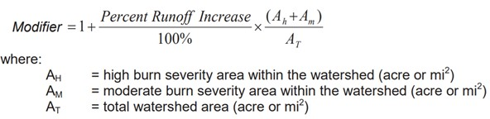

The Percent Runoff Increase for higher frequency events such as 5-, 10-, 25-, and 50-year floods have shown to be higher than those of less frequent higher discharge events. Table 3‑4 shows the percent runoff increases used for all events in this study.

Table 3‑4: Percent Runoff Increases

|  |  |  |  |  |  |  |  |
| --- | --- | --- | --- | --- | --- | --- | --- |
| 2YR | 5YR | 10YR | 25YR | 50YR | 100YR | 200YR | 500YR |
| 305% | 230% | 195% | 150% | 120% | 100% | 95% | 85% |

The tool allows the user to toggle on and off a burn field for each HUC12 in the study area, showing the impact to the area weighted runoff modifier to various main stem reaches that may have multiple contributing HUC12s, or showing what the estimated multiplier may be for smaller tributaries within a HUC12.

The combined area of high and moderate burn severity specified in the equation above was approximated by default, using the wildfire hazard potential determined by the U.S. Department of Agriculture (USDA) Forest Service. Wildfire Hazard Potential identified as very high, high, or moderate by the Forest Service was a best estimate of the area likely to make up the moderate or high burn severity areas. The option is provided to allow the user to override this estimate and provide the sum of moderate and high burn severity areas determined by following a wildfire or if estimated by other means.

Digital shapefiles of the HUC12s within the study area and main stem reaches have been provided as well as an Excel file that allows for the computation of the modifiers discussed above.

# One-Dimensional Hydraulic Analysis

Steady flow HEC-RAS models were developed for the 10%, 4%, 2% 1%, 1% minus, 1% plus, and 0.2% flood events. The flow chart in Appendix 2 depicts the process for 1D HEC-RAS model development and floodplain delineation. HEC-RAS model geometry was initially developed for the 1% event using automated tools and simplified assumptions such as a single conveyance area and composited single Manning ‘n’ values. The model geometry was then refined manually in addition to other automated processes, and other flow events added. The HEC-RAS model components are described in the bullets below:

* Hydro-enforced stream centerlines
* Cross sections that generally contain the 100- and 500-year flows
* Ineffective flow areas as appropriate at inline structures and non-conveyance areas based on the 100-year flow
* Structure locations and dimensions from National Bridge Inventory (NBI) bridges and culverts dataset, dated July 2017
* Bounding cross sections at hydraulically significant structures where dimensions were not available in the NBI inventory
* Weir flow cross sections at ponds/reservoirs and some roads
* Bank stations and overbank flow paths
* Bank-channel-bank Manning n values based on the 2016 National Land Cover Database (NLCD)
* Normal depth downstream boundary conditions based on the 100-year flow

No supercritical flows were permitted in the models, so the lowest possible water surface elevation for any cross section was critical depth.

The water surface profiles and floodplains for the 1% and 0.2% flood events were reviewed in detail. Dips in the water surface elevations were removed where possible, otherwise their locations are documented in the issue polygon. The water surface profiles for the 10%, 4%, 2%, 1%, and 0.2% were reviewed and models edited to ensure that there were no crossing profiles for the listed events..

The deliverables include the following:

* HEC-RAS models for every stream including all the flood events described above
* Spatial files with the stream centerlines and cross sections attributed with flows and water surface elevations for the 10%, 4%, 2%, 1%, 1% plus, 1% minus and 0.2% flood events
* Backwater processed floodplain polygons and corresponding water surface elevation grids for the 1% and 0.2% flood events
* BFE proxy cross sections with the 1% water surface elevation.
* Point files where the stream centerline crosses the Tiger Roads layer, which was used to identify road crossings
* Shapefiles with the locations and assumed dimensions for the modeled bridges and culverts
* Issue polygons identifying special issues (water surface dips, tie-in locations with 2D BLE models or effective data, unique features, etc.). These are in the Areas of Special Interest (AOSI) layer in the delivered BLE database

Appendix 1 includes a description of the deliverable format and geodatabase schema.

The following sections present additional detail regarding the model components and parameters as well as floodplain processing and the development of BFE proxy cross sections.

## Discharges

Discharges for the 10%, 4%, 2%, 1%, 1% plus, 1% minus, and 0.2% events were derived from the final flow grids and imported into HEC-RAS using automated tools.

## Boundary Conditions

The downstream boundary condition was set to normal depth based on the 1% event flow.

## Stream Centerlines

The hydrologic flow paths were used as the basis for the stream centerlines. Rough models with closely spaced cross sections were developed with these lines using a low flow rate. Based on the results and the terrain, an automated process was used to locate the thalweg and then smooth the lines based on a splining operation.

The splined streamlines were reviewed and editing manually where needed to ensure the streamlines were located near the thalweg in the low flow channel.

## Cross Sections

Automated processes were used to create the cross sections with input parameters defining cross sections spacing and width. The spacing and width may vary along a stream based on the terrain and 1% and 0.2% flood extents. In general, the cross section spacing was on average 200 feet. However, spacings of 50 to 100 feet were used in steep and small streams.

All cross sections were reviewed and manually edited where needed to ensure alignment perpendicular to the flow and flow containment. Some cross sections were added where needed in steep areas to ensure that the streamline was wet. Bounding cross sections were placed at hydraulically significant inline structures and at high points where weir flow occurs.

At inline reservoirs, cross sections were generally placed at the toe and at the upstream face at the emergency spillway elevation. Based on engineering judgement, locational cross sections were place along the length of the emergency spillway at some locations.

## Ineffective Areas

Normal ineffective flow limits were added as appropriate at inline structures and non-conveyance areas. The limits were based on the 1% flood event and were not refined for other recurrence intervals.

## Channel Banks and Overbank Flow paths

Channel bank station locations and overbank flow path lengths were created using an automated process that incorporated hydraulic model results of preliminary models to ensure the application of reasonable bank station locations and the use of a repeatable process that could be applied to all reaches in the study. A low flow event such as the 2-year event is run through the preliminary hydraulic model, then the floodplain boundary for that event was used as the main basis for the bank stations. Additionally, a minimum and maximum distance from the stream centerline was specified to remove outlier bank station locations that may have been reported by the low flow hydraulic model. Bank station lines were also reviewed globally for reasonableness and modified for some locations where necessary.

Overbank flow path lengths, or downstream reach lengths were determined from a simplified bank station line. The line was simplified such that the flow path length was determined by the minimum distance from the bank station at any cross section with the shortest distance to the bank station of the downstream cross section.

## Manning’s n Values

Manning’s n values were assigned to each class in the NLCD 2016 land cover. The correspondence between land use codes and the Manning’s n-values are provided in Appendix 4. For each model cross section, the n-value for each of the three sections of the cross section left overbank, channel, and right overbank were selected by using the n-value corresponding to the most common land-use code in that portion of the cross section. For each land use code two different Manning’s n values were specified, one for use in overbank areas and one for between the channel bank stations. The methodology to assign two different Manning values was adopted based on the resolution of the NLCD data which does not typically reflect changes in land cover within the low flow channel areas. Without a decrease of Manning n for channel portions of the cross section, values would likely be excessive and result in overly conservative water surface elevations. In practice, even in land uses with high Manning values within the low flow channels exist small corridors with relatively low Manning n values; this approach approximates those observations.

## Expansion and Contraction

Default contraction and expansion coefficients (0.1 and 0.3) were used.

## Bridges and Culverts

Bridges and culverts included in the National Bridge Inventory (NBI) were used in the models. Some of the structure dimensions were included in the database, while others were assumed based on some design guides and dimensions analyzed within other studies.

For the bridges, the pier width and the deck thickness were not included in the database. Table 4‑1 and Table 4‑2 show the assumed dimensions as a function of the average span width.

Table 4‑1: Assumed pier widths as a function of average span width

|  |  |
| --- | --- |
| Average Span Width (feet) | Pier Width (inches) |
| Less than or equal to 25’ | 24” |
| Between 25’ and 50’ | 36” |
| Greater than 50’ | 48” |

Table 4‑2: Assume deck thickness as a function of average span width.

|  |  |
| --- | --- |
| Average Span Width (feet) | Deck Thickness (inches) |
| Greater than or equal to 140’ | 96” |
| 120’ < width ≤ 130’ | 90” |
| 110’ < width ≤ 120’ | 84” |
| 100’ < width ≤ 110’ | 78” |
| 90’ < width ≤ 100’ | 72” |
| 80’ < width ≤ 90’ | 60” |
| 70’ < width ≤ 80’ | 54” |
| 60’ < width ≤ 70’ | 48” |
| 50’ < width ≤ 60’ | 42” |
| 40’ < width ≤ 50’ | 36” |
| Less than or equal to 40’ | 30” |

For culverts, the NBI data included the number of barrels, type of material, maximum width, and average width. The following assumptions were made regarding the culvert dimensions:

* The smaller of the maximum width and average width was used
* The height of the culvert could not exceed the width, but the top of the culvert must be at least 2 feet below the top of road
* Inverts were assumed to be the same as or up to one-half foot above the channel invert
* Aerial photography was used to estimate the length and the shape

## Special Issues

Polygons identifying locations of special issues are included in the deliverables.

There are several locations where there are dips in the profiles for the 1% and 0.2% events. The dips were less than 0.05 foot and located in backwater areas of ponds/reservoir and are documented in the AOSI polygon.

There are effective Zone A areas within the gravel mining activities. Several Zone A streams are no longer present in the LIDAR topography and therefore were not modeled. There is an AOSI polygon identifying the location of these streams.

In most cases, levees were ignored, and water surface elevations and floodplain delineations were determined with the assumption that flow outside of the levees provided effective conveyance.

To prevent the channel from drying out, ineffective flow areas were generally used to confine the flow to most perched channels resulting in conservative floodplains and water surface elevations.

## Floodplains and Water Surface Elevation Grids

Floodplains were generated for the 1% and 0.2% annual chance exceedance events for the hydraulic model reaches. These floodplains were utilized to determine if the hydraulic model results looked reasonable, and if the models needed adjustment.

The floodplains are based on water surfaces interpolated from the hydraulic model cross sections. In most locations where flow containment was lost at the limits of the models, backwater conditions were considered, and the floodplains adjusted with an automated post-processing step to include additional backwater areas. Figure 4‑1 shows backwater that was added beyond the limits of the hydraulic model. Figure 4‑2 shows an example of backwater that required additional area because the water surface elevations extend upstream beyond the upstream limits of most models.

For locations where the models overlap, e.g. at confluences, the highest water surface elevation across all models dominates and results in the largest delineated floodplain by definition.

Dams and reservoirs are accounted for by simply placing a model cross section along the upstream face of the dam at the same elevation as the emergency spillway.

Water surface and depth grids were created for the 10%, 4%, 2%, 1%, 1% plus, and 0.2% events.

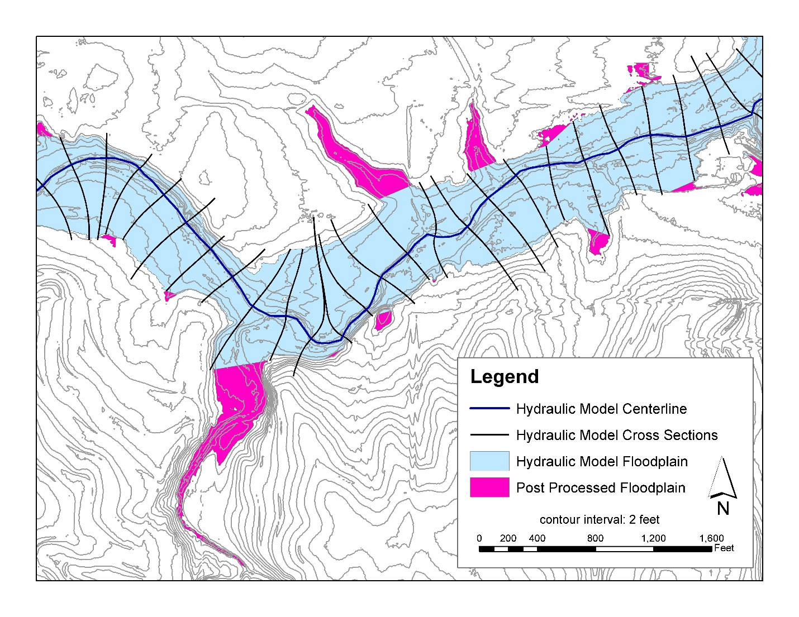

Figure 4‑1: Post processed floodplain to add backwater areas along a modeled reach that would be flooded but were not reflected in the hydraulic model, typically these occur as small tributaries join a larger reach.

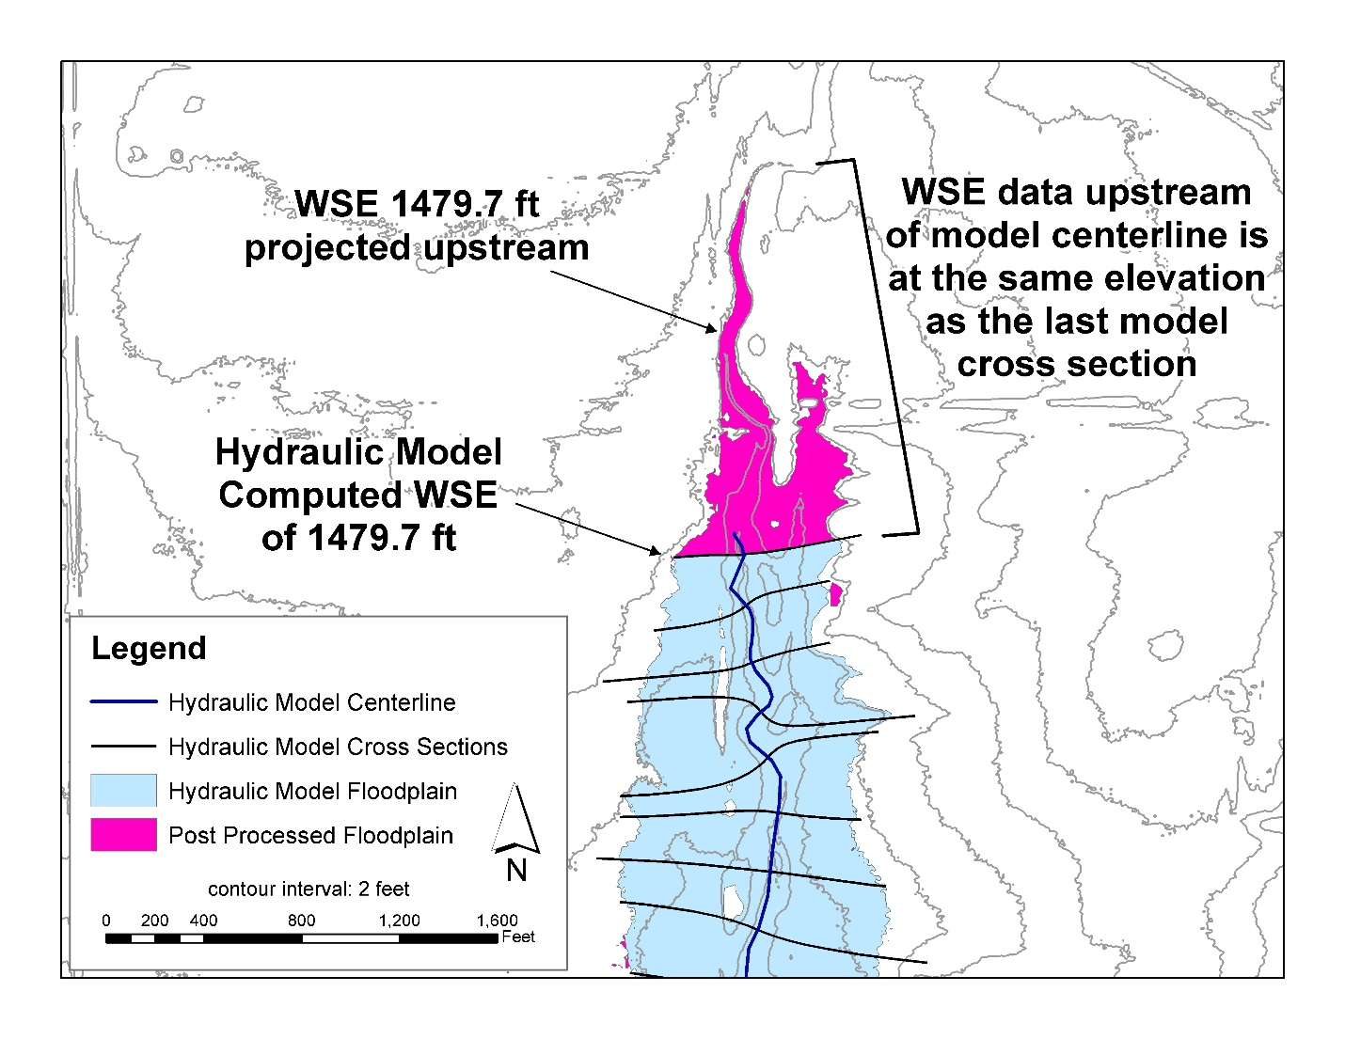

Figure 4‑2: The post processing of floodplains also adds backwater areas upstream of the hydraulic model, these areas have the projected water surface from the most upstream cross section.

## BFE Proxy Cross Sections

Base Flood Elevation (BFE) proxy cross sections were developed to provide computed water surface information from the 100-year flood profile in a user-friendly format. From the hydraulic model cross sections, a processed version of cross sections was created that removed overlapping cross sections. Cross sections often overlap and intersect at stream confluences or along parallel portions of reaches. In areas with overlapping cross sections from multiple models, the cross sections with the most representative extents and water surface elevation (most commonly the higher water surface elevation dictates) were left in place. Occasionally water surface elevations may be computed to slightly decrease in the upstream direction, in these cases cross sections with decreasing flood elevations were often removed.

The end result of the process is a set of hydraulic model cross sections that reflect the flood elevation and extents in the areas for which they are present, similar to BFE lines that appear on FEMA Flood Insurance Rate Maps.

## Quality Review

Self-checks and review comments and their resolution are documented in spatial files and the checklists in Appendix 4.

# Two-Dimensional Hydraulic Analysis

Based on review of topography, aerial photography, and knowledge of the historical flow patterns in the area, it was anticipated that many areas identified during the discovery process with a need for flood hazard assessment could not be adequately identified or quantified using one dimensional modeling techniques alone. There are locations in the study area that have distributary flow paths and areas of shallow flooding. HEC-RAS 2D was used to model these areas while following the basic methodologies of BLE: modeling reaches independently, allowing unimpeded flow through structures such as bridges and culverts, and using gridded hydrology for input discharges.

Two-dimensional hydraulic models were created utilizing the same topographic, land cover, and hydrologic data that formed the foundation for 1D BLE analysis. Generally, the modeling methodology is not to allow man-made structures such as spur dikes, levees, and particularly road embankments to provide flood protection other than large scale engineered projects such as those seen in the figure below.

Road embankments such as those seen in Figure 5‑1 and Figure 5‑2 below are reviewed following initial model runs to determine necessary action to allow flow to pass undeterred or through identified locations in a way to approximate locations for culverts or bridges. In Figure 5‑1, the road alignment relative to the mesh alignment allows for flow to pass through the culverts that are assumed to be present based on review of aerials.

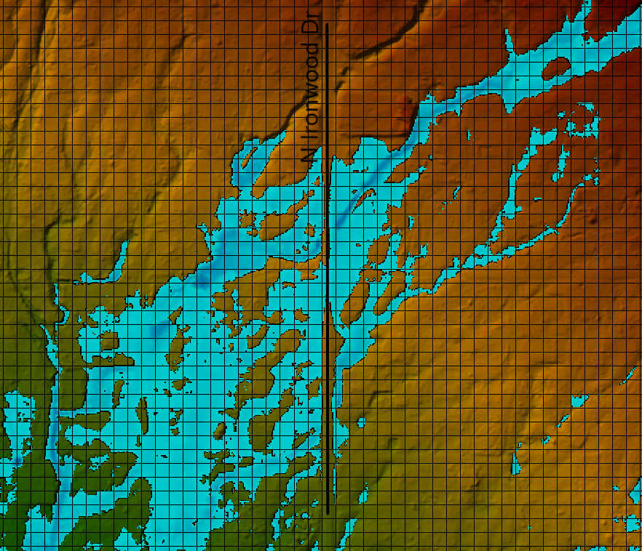

Figure 5‑1: Mesh alignment allows for flow across road embankment

In Figure 5‑2,the mesh created during automated model set-up produced cell boundaries along the top of the road embankment. Leaving this alignment in place would cause unrealistic impediment to the flow and conservative floodplain upstream of the road. Review of available imagery showed the ability for flow to pass through via many culverts. To allow flow to pass through the embankment, cell sizes are modified along the road and flow characteristics are reviewed in subsequent model runs.

Figure 5‑2: Larger roads or grid alignment may require adjustment of the grid to prevent flow impediment

Hydraulic model results for all individual reaches modeled and for all areas within the project are gathered and processed so that the following deliverables can be provided:

* Water surface elevation grids for the 10%, 4%, 2%, 1%, 1% plus, and 0.2% events.
* Depth grids for the 10%, 4%, 2%, 1%, 1% plus, and 0.2% events.
* Floodplain delineations for the 1% and 0.2% evented based on depth thresholds of 0, 0.5, 1 and 3 feet provided as polygons

## Floodplain Mapping for 2D Model Results

Floodplain delineations from the HEC-RAS 2D models are used to create the 1% and 0.2% annual chance floodplains. Following process describes the standard methodology to address the typical challenges encountered for cleaning the 2D modeling results. Typical challenges include,

* Possibility of maximum water surface elevation results depict both pluvial (surface / sheet flow) and fluvial (riverine) flooding.
* the floodplain may be mapped for areas with small drainage areas (less than 1 square mile) and
* in areas of very shallow flooding.

Standard methodology or steps followed to clean up the original floodplain delineations from HEC-RAS models as follows

1. Identify main flow paths and engineered channels based on the following criteria. Note that all streams must have at least one main flow path and a stream centerline to delineate

* Current effective floodplains
* Streams identified in NHD / USGS or CNMS
* Flow accumulation
* Topography

1. From the model, within RAS or GIS, create inundation polygons from the depth grids, for zero-depth and other depth thresholds (typically 0.5’, 1.0’ and 3.0’).

* These polygons will be used to determine mapping and depths for shallow flooding areas. Since depth polygons created below 1 foot may be used for mapping limits (see Step 4), they require consideration. A depth polygon of 0.5’ feet or less is typical. Anything greater than 0.5’ is strongly discouraged and justification is required.
* These inundation polygons are used to identify the shallow flooding areas and possible Zone AO or Shaded Zone X areas. Examine the other depth polygons for overbank and shallow sheet flooding based on the highest risk. Shallow depth can be represented by any depth below 3.0’, typically in whole foot intervals (ex: Zone AO (1’), Zone AO (2’)). This step is not completed as part of the mapping cleanup for this study.
* Determine areas that may meet the Shaded Zone X definition (average depths less than 1 foot). Note that Shaded Zone X is not intended for use on the edge of other zones (A or AE) to filter out depths from the floodplain. This step is not completed as part of the mapping cleanup for this study.

1. Create a drainage area accumulation grid or polyline (or similar process to identify drainage area accumulation). Processes available for determining drainage area accumulation may include ESRI ArcHydro, ESRI GIS processing tools, and USGS StreamStats.
   1. Note that sinks may require filling for some methods to work.
   2. A manual method can be used, if automated processes or software is not available, with topography to create drainage subbasin boundaries to determine the point of accumulation above the 1 sq mi threshold. Any drainage accumulation over 1 sq mi must be mapped.

c. Examine flow avulsion areas. If an upstream avulsion or split causes flow to enter another stream or flow path, include the entire upstream area as the drainage area.

1. Examine the effective mapping limits. If using spatial software, bring in the effective mapping SFHA. Include all streams regardless of drainage area that have effective mapping, unless proper justification is provided to remove the effective mapping.
2. Using the drainage area accumulation with other included streams as the guide to determine use of the inundation polygons as follows.

* Examine the areas against the ‘overbank_filter_areas’ polygon that may have been created for shallow flooding areas. Use the ‘shallow flooding inundation polygon’ (typically 0.5 ft or less) in the overbank filter areas.

For most streams and main streams with a drainage area greater than 1 sq mi (or other project threshold but in no case exclude DA > 1 sq mi), use the ‘rain-on-grid zero-depth’ polygon for mapping.

# Deliverables

All the digital data developed as part of this BLE study is organized in the following folder structure and also achieved on FEMA’s Mapping Information Platform (MIP) under case number 20-09-0049S.

* General
  + This report in word and PDF format
* Hydraulic_Models
  + HECRAS_Models_Final - HEC-RAS models organized by HUC-10 folder
    - Spatial index file to locate the HEC-RAS model location
  + 2D_HECRAS_Models_Final - HEC-RAS models organized by HUC-10 folder
    - Spatial index file to locate the HEC-RAS model location
* Spatial_Data
  + All the spatial files associate with BLE study including 1% and 0.2 % floodplain mapping, Water Surface Elevations grids, Depth Grids, Stream centerlines, Cross-sections, and proxy BFE data
* Supplemental_Data
  + Hydrology datasets
  + Terrain datasets
  + Spatial files identifying locations of modeled bridges and culverts, road sections, and inline reservoirs
  + NBI and Tiger Roads layers

The HEC-RAS models have been created for the following flood profiles: 10%-, 4%-, 2%-, 1%-, and 0.2%-annual-chance events. Two additional profiles the 1%-plus and 1%-minus have been created, that alter the 1%-annual-chance profiles based on the standard error reported for applicable regression equations.

For all these profiles the same HEC-RAS geometries are used.

The Hydraulic_Models folder contains the study stream index and five folders for the all the HUC-10 watersheds studied. Each HUC-10 folder contains the individual hydraulic models for each stream. The Streamline_Model_Index spatial file provides the location of the study streams and their corresponding model number and associated folder structure. Figure below shows the hydraulic model folder structure.

Inside each folder, for a given event, there are folders for each individual reach (each reach has been assigned a reach number that is assigned to the folder).

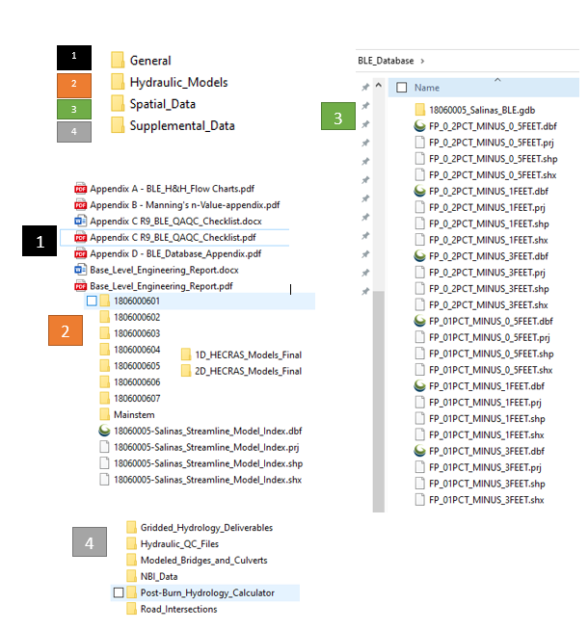

Figure 6‑1: BLE deliverable folder structure

# References

NHD Plus (<http://www.horizon-systems.com/nhdplus/>)

National Elevation Dataset (NED) 1/3 arcsecond (about 10 meter) rasters, downloaded from <ftp://rockyftp.cr.usgs.gov/vdelivery/Datasets/Staged/Elevation/13/GridFloat>

Paretti, N.V., Kennedy, J.R., Turney, L.A., and Veilleux, A.G., 2014, *Methods for Estimating Magnitude and Frequency of Floods in Arizona, Developed with Unregulated and Rural Peak-Flow Data through Water Year 2010,* U.S. Geological Survey Scientific Investigations Report 2014-5211.

Procedure to Calculate Post-Burn Flow Discharges for BLE Projects” memorandum provided to the Region in November 2018.

USGS, 2019, National Land Cover Database 2016, downloaded from [NLCD 2016 Land Cover (CONUS) | Multi-Resolution Land Characteristics (MRLC) Consortium](https://www.mrlc.gov/data/nlcd-2016-land-cover-conus)

USGS and Woolpert, 2019, *CA AZ FEMA R9 2017 D18 Airborne Lidar Report*, July 2019.

Region IX Geodatabase Documentation

BLE Hydrologic Process Flowchart

BLE Hydraulic QAQC Checklist

Manning’s n Values