Note to HEC-RAS users:

The message for Agave Wash: 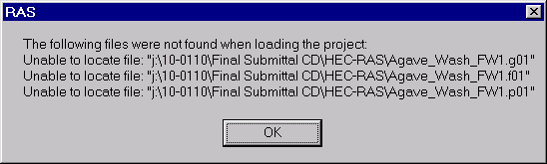
Is normal, and these files are not needed to use the HEC-RAS files for this project.

The final project files are:

Agave_Wash_FW1.prj
Agave_Wash_FW1.p02
Agave_Wash_FW1.g02
Agave_Wash_FW1.f02
Agave_Wash_FW1.r02
Agave_Wash_FW1. O02

